**Christmas Lights Animation**

By: Austin Wentz and Jordan Doell

Interactive Lighting

4/20/2013

Interactive Lighting Client User Guide

# Table of Contents

Table of Contents

Table of Contents 1

Purpose 2

Main Menu 2

Sequences: 2

Manual: 2

Remote Play: 3

Installation: 4

Settings: 4

Maintenance: 5

# Purpose

This XBMC add-on was developed for the Christmas Lights Animation Project. This add-on will allow the user to animate Christmas lights with or without music from within XBMC. This guide will show the different modes available within the add-on.

# Main Menu

This is the initial view that you see when the add-on opens.

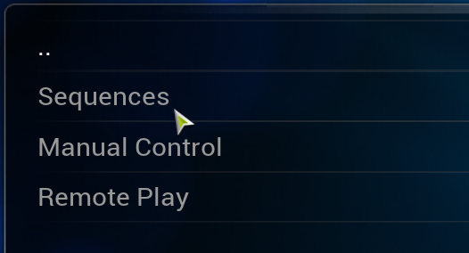

# Sequences:

This mode allows you to play songs and lighting sequences from the client itself. Select this mode by clicking on it. It will bring you to a list of songs which have lighting sequences associated to them. To play a sequence click on the sequence you wish to play, then click on the sequence file to begin the sequence.

# Manual:

This mode allows the iOS application to manually control the different strands of light. Select this mode by clicking on it; once you are done using this mode press the Esc key.

# Remote Play:

This mode allows the iOS application to play songs and lighting sequences remotely. Select this mode by clicking on it; once you are done using this mode press the Esc key.

# Installation:

Since this is an add-on to XBMC, you must have XBMC installed before you can use this. Once XBMC is installed, copy the plugin.video.interactivelighting folder into the XBMC/addons folder. That is all that needs to be done. You should see the Interactive Lighting add-on under both video and music add-ons within XBMC. Once the add-on is visible, then you will need to configure the add-on with the appropriate settings.

# Settings:

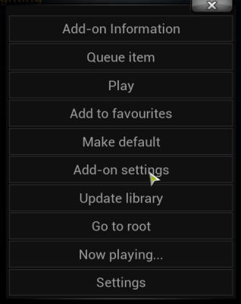

To use the add-on properly, it first needs to be configured. To access the settings, right click on the add-on within XBMC and click Add-on Settings as shown in the picture. This will bring up the settings menu which looks like:

These settings all need to be configured correctly.

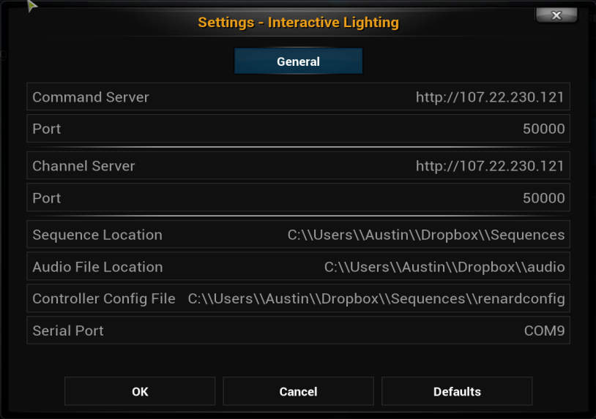

# Maintenance:

The client add-on should not need much maintenance. However, should the user need to add more songs to the system, there are a few simple steps for adding songs to the client. However, since this is not part of using the app, the information involved with adding songs will be provided in the Software Design Document.